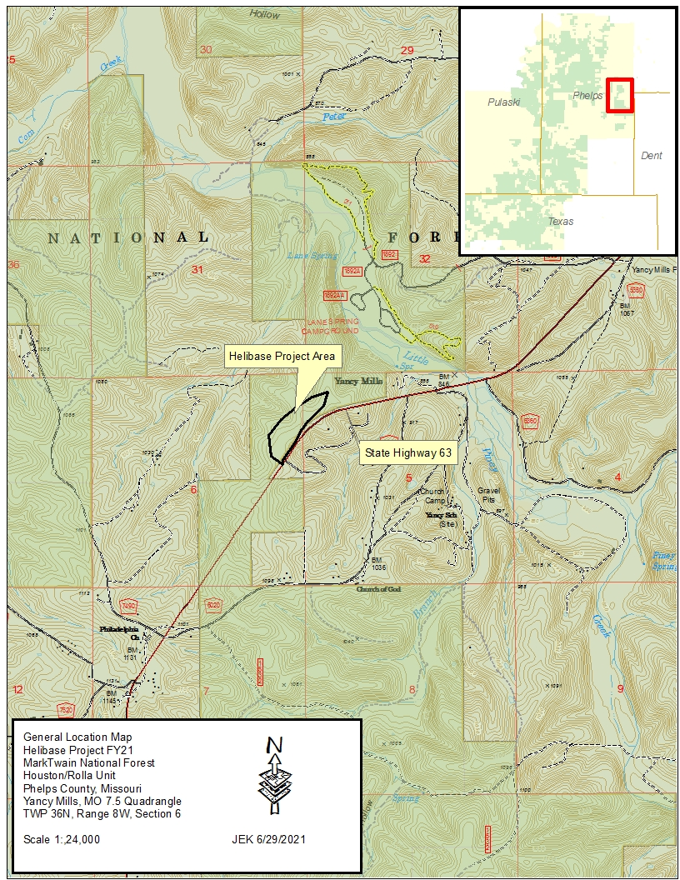
Project is located approximately 10 miles south of Rolla off State Highway 63 located on the West Side of Road.

